Analysis of the Model
# Analyzing the Model with different fields
# View the names of input training data
names(trainingSet_days)
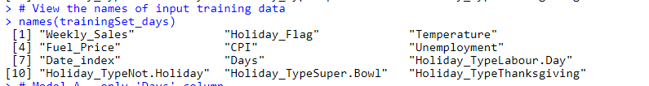

# Model A - only 'Days' column
Model.A = lm(formula = Weekly_Sales ~ Days , data = trainingSet_days)
summary(Model.A)
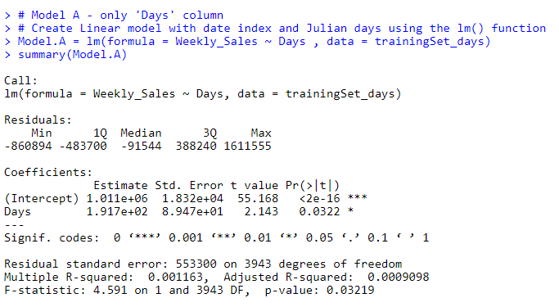

# Model B - only Days, 'Holiday_Flag' column
Model.B = lm(formula = Weekly_Sales ~ Days + Holiday_Flag , data = trainingSet_days)
summary(Model.B)
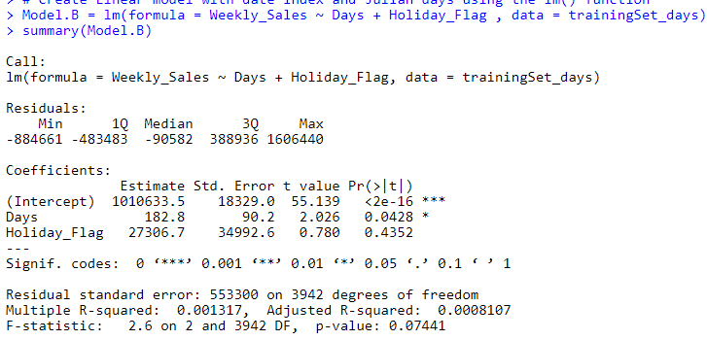
# Model C - only Days, 'Holiday_Flag',Fuel_Price column
Model.C = lm(formula = Weekly_Sales ~ Days + Holiday_Flag + Fuel_Price , data = trainingSet_days)
summary(Model.C)
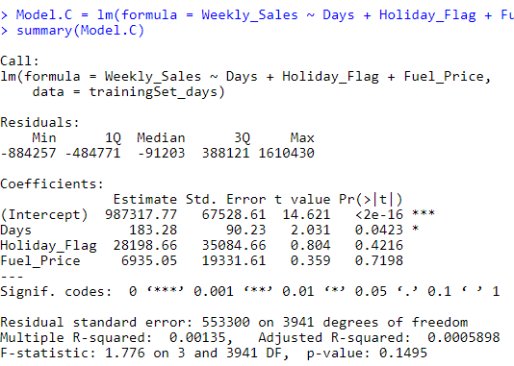

# Model D - only Days, 'Holiday_Flag',Fuel_Price,Date_index column
Model.D = lm(formula = Weekly_Sales ~ Days + Holiday_Flag + Fuel_Price +Date_index, data = trainingSet_days)
summary(Model.D)
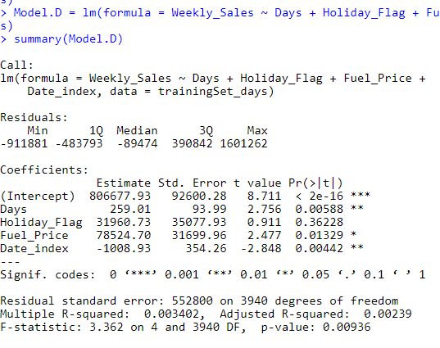
# Model E - only Days, 'Holiday_Flag',Fuel_Price,Date_index,Temperature column
Model.E = lm(formula = Weekly_Sales ~ Days + Holiday_Flag + Fuel_Price + Date_index + Temperature, data = trainingSet_days)
summary(Model.E)
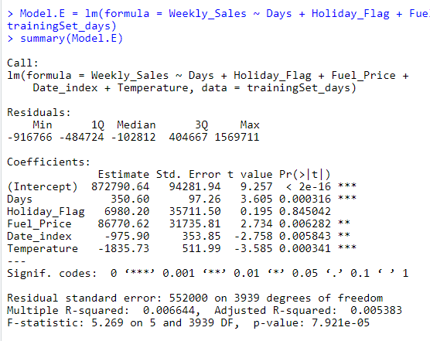

# Model F - only Days, 'Holiday_Flag',Fuel_Price,Date_index,Temperature,CPI column
Model.F = lm(formula = Weekly_Sales ~ Days + Holiday_Flag + Fuel_Price + Date_index + Temperature + CPI, data = trainingSet_days)
summary(Model.F)
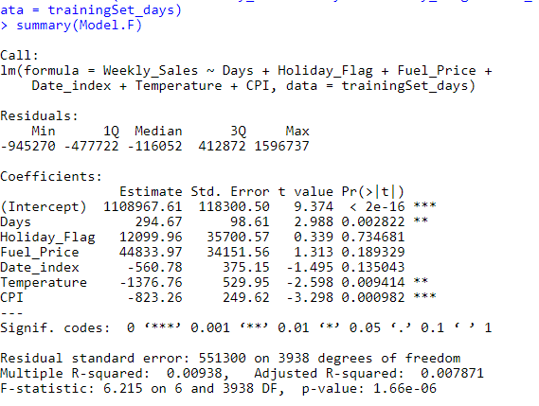
# Model G - only Days, 'Holiday_Flag',Fuel_Price,Date_index,Temperature,CPI,Unemployment column
Model.G = lm(formula = Weekly_Sales ~ Days + Holiday_Flag + Fuel_Price + Date_index + Temperature + CPI + Unemployment, data = trainingSet_days)
summary(Model.G)
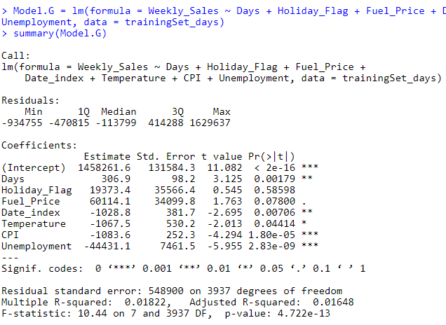
# Model H - only Days, 'Holiday_Flag',Fuel_Price,Date_index,Temperature,CPI,Unemployment,Holiday_TypeLabour.Day
Model.H = lm(formula = Weekly_Sales ~ Days + Holiday_Flag + Fuel_Price + Date_index + Temperature + CPI + Unemployment + Holiday_TypeLabour.Day, data = trainingSet_days)
summary(Model.H)
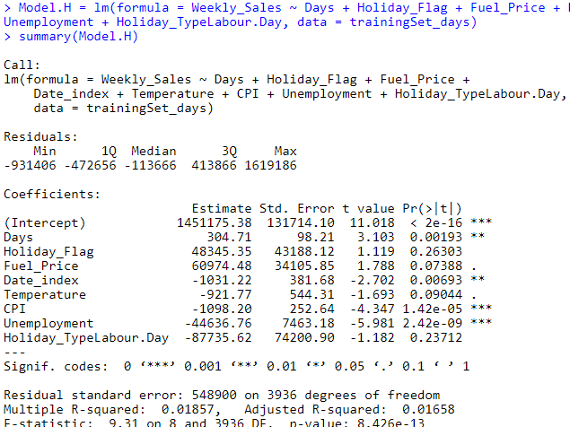
# Model I - only Days, Holiday_Flag', Fuel_Price,Date_index, Temperature , CPI,#Unemployment,Holiday_TypeLabour.Day,Holiday_TypeSuper.Bowl
Model.I = lm(formula = Weekly_Sales ~ Days + Holiday_Flag + Fuel_Price +
Date_index + Temperature + CPI + Unemployment +
Holiday_TypeLabour.Day + Holiday_TypeSuper.Bowl, data = trainingSet_days)
summary(Model.I)
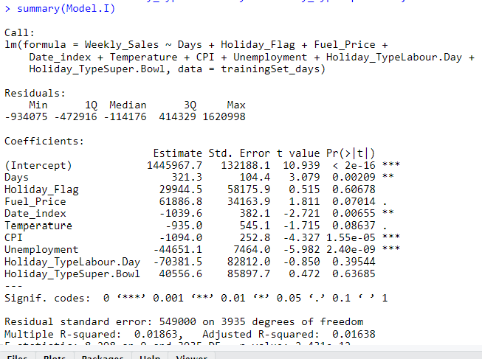
# Model J - only Days, 'Holiday_Flag',Fuel_Price,Date_index,Temperature,CPI,
#Unemployment,Holiday_TypeLabour.Day,Holiday_TypeSuper.Bowl,Holiday_TypeNot.Holiday
Model.J = lm(formula = Weekly_Sales ~ Days + Holiday_Flag + Fuel_Price +
Date_index + Temperature + CPI + Unemployment +
Holiday_TypeLabour.Day + Holiday_TypeSuper.Bowl +
Holiday_TypeNot.Holiday, data = trainingSet_days)
summary(Model.J)
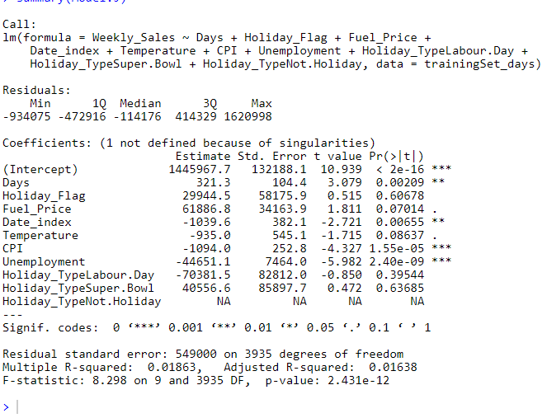

Model with all the fields in the data frame gives higher Rsquared value.
Linear model with date index and Julian days using the lm() function
model_days = lm(formula = Weekly_Sales ~ . , data = trainingSet_days)
summary(model_days)

